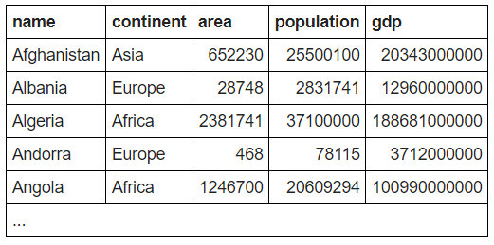

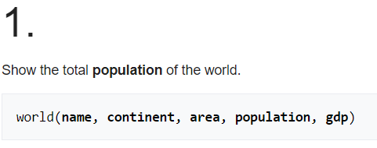

**SELECT SUM(population) FROM world**



**SELECT DISTINCT(continent) FROM world**



**SELECT SUM(gdp) FROM world WHERE continent LIKE 'Africa'**

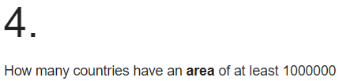

**SELECT COUNT(name) FROM world WHERE area >= 1000000**

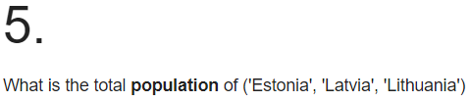

**SELECT SUM(population) FROM world WHERE name IN ('Estonia','Latvia','Lithuania')**

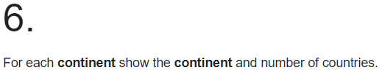

**SELECT continent,COUNT(name) FROM world GROUP BY continent**

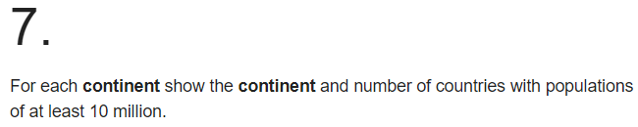

**SELECT continent,COUNT(name) FROM world WHERE population >= 10000000 GROUP BY continent**



**SELECT continent FROM world GROUP BY continent HAVING SUM(population) >= 100000000**